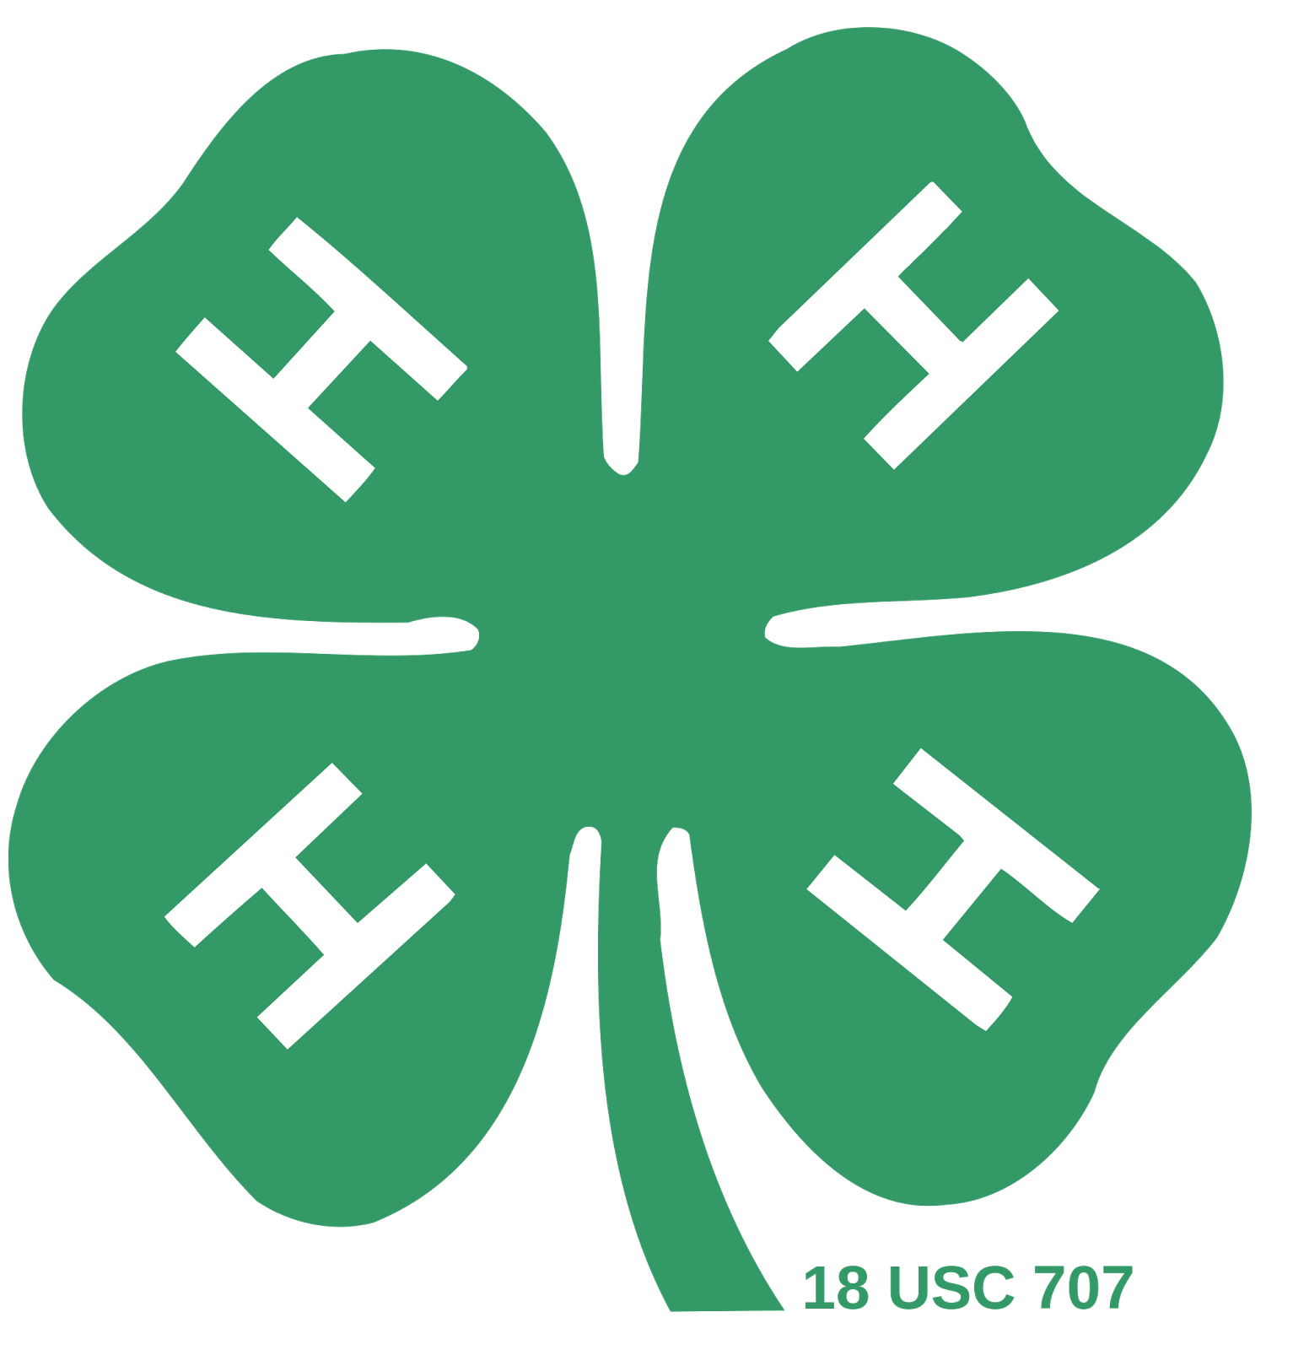

San Bruno/SSF Minutes

Date: 10/12/2016

* Preceding: Muriel Butler (Doug Bernal couldn’t attend this evening)
* Call to Order (time): 19:05 (7:05) PDT
* Flag Salute/4-H Pledge
  + - * Flag Salute: Ryan Olson
      * 4-H Pledge: Ryan Olson
* Treasurer’s Report:
  + Standard payments
  + June: $29,773.61
  + Ending October: $29,573.43 (?)
* Secretary’s Report:
  + Minutes PASSED
* Misc. Officer Reports:
  + Recreation: Bowl Game!
* Farm Reports (including Community Leader):
  + Farm Boss: Not much; some improvements
  + Community Leader:
    - Leadership training
    - Cow Palace event/bunny show!
* Old Business:
  + - County Council meeting was September 26
    - Farm Clean-up: cleaned up farm + improvements!
    - Open House-September 17 (we did well!)
    - Enrollment due/Farm rules/requests were due
    - Club Sweatshirts: approved and order forms are available
    - Bee Project: off the farm by December
* New Business:
  + - New steer coming! (Muriel- UPDATE tonight)
    - Halloween Party: plans and sign-up
    - Community Service: food drive; bring next meeting
* Next Meeting:
  + - November 9, 2016
* Program/Recreation
  + - Bowl Game!
    - Raffle
    - Introduction to 4-H!

Date of Minutes Approval: **November 6, 2016**

**Approved by: Your President, Muriel Butler**

Approved by: Your Secretary, Ryan Olson